Model | PAFC-F10A
Packaging materials | Spice powder, chili powder, milk powder, protein powder, seasoning powder, onion powder, ginger powder, etc
Container size | Φ30-160mm, H50-260mm
Filling weight | 30-100g (can be customized)
Filling accuracy | ≤500g, ≤±1% / ＞500g, ≤±0.5%
Filling speed | 55-75 bpm
Voltage | 3P, AC208-415V, 50/60HZ
Air compression | 6 kg/cm², 0.05 m³/min
Power | 2.3KW
Machine weight | 390 kg
Outline dimension(mm) | 2000*1070*2120 mm
Hopper capacity | 50 L/hopper

Application:
High speed powder little bottle rotary filling machine is suitable for automatic filling of various powder products, such as spice powder, chili powder, milk powder, protein powder, seasoning powder, onion powder, ginger powder, etc.
Kindly Reminder:
We have an experienced team of R & D engineers who can customize packaging solutions according to your product characteristics.
Packing Examples:
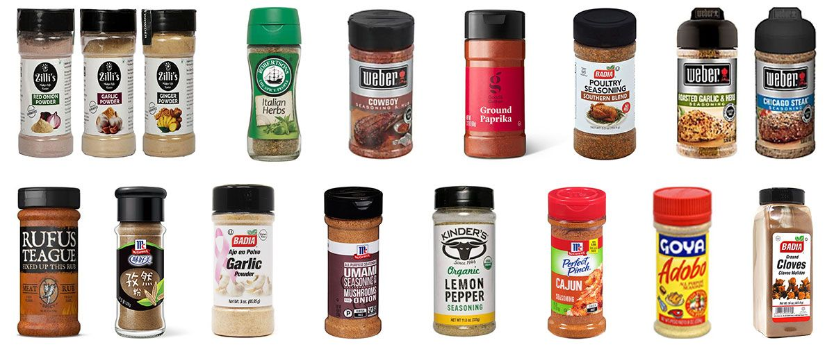

- Smart Touch Screen: color interface and easy to operate
- Openable Material Hopper: food grade material and washable
- Rotary Feeding Mechanism: high filling accuracy and speed, graetly improve working efficiency
- Mechanism For Separating Bottles Individually: screw bottle splitter, separating bottles quickly, strong versatility

