Performance features:
- Stable: industrial grade weighing module and PLC control system are used, weighing is stable and accurate.
- Fast speed: the combination of gravity feeding and vibration feeding, double weighing scale alternates to measure and feed.
- High precision: stepwise multi-speed cutting, small error.
- Automatic calculation: The system will automatically calculate the fast weight and slow weight, and automatically adjust the error.
- Structural stability: a weighing scale bucket corresponds to a vibrator and a weighing sensor, which are independent of each other.
- Simple operation: equipped with electronic touch screen, weight parameters can be directly input, the system can automatically calculate parameters and track and correct error values.
- Stable feeding: the feeding system has a time function, and the material can be supplied normally even when the material level probe fails.
- Two types of feeding: photoelectric induction and foot pedal switch feeding compatible.
- Easy to clean: the open design around, the dust cover can be opened, and the interior is easy to clean.
- Convenient to move: the bottom is equipped with a brake wheel.
technical parameter:
packing specifications | 500g-25kg (depending on the material weight)
Packaging speed | 600-1500 bags/hour (determined by packaging weight, material weight, etc.)
Scale capacity | 29 L
Packaging accuracy | ≤±0.2% (determined by packaging weight and material weight)
source | AC220V 50hz
power | 0.8kw
outline dimension | L1000 × W750 × H233 0mm
Working principle (weighing):
0-4.8KG: Free flow feeding
(weighing)
The material enters the self-flowing hopper
The material falls quickly by its own gravity
(Cylinder controls the opening and closing of the hopper)
4.8-4.93KG: Vibration for quick feeding
(weighing)
The vibrating trough begins to vibrate rapidly to discharge
After reaching "fast weight gain", the speed slows down
4.93-5KG: slow vibration feeding
(weighing)
The vibrating trough begins to vibrate slowly and discharge
Stop feeding after reaching "slow weight gain"
"4.8KG" "4.93KG" is just an example, the specific value needs to be determined according to the actual situation

outline dimensional drawing:
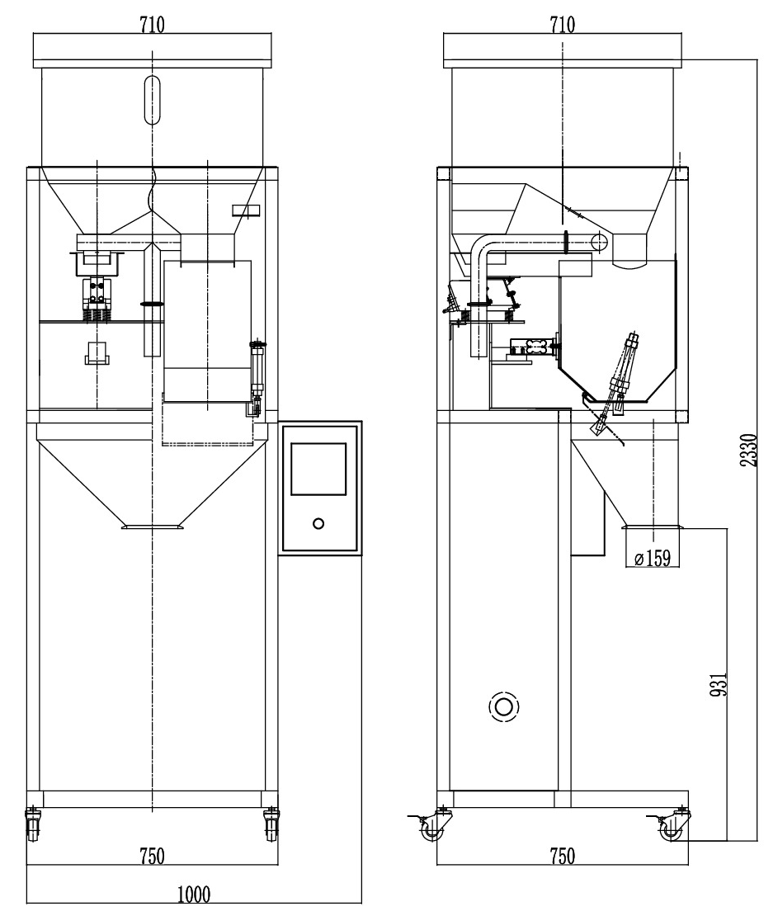

Note: The volume of the two scales can be customized into 42L and other specifications according to the demand

