 | PPG-50F
 | Automatic Powder Filling And Capping Machine
Filling Volume | 3 - 500ml (with screw change)
Filling speed | 30 - 50B/min
Filling Precision | 0.75%
Finished product rate of cap drop | ≥99％
Main machine power | 380V/220V 50 - 60Hz 2500W
Dimensions | 2400×1100×1800mm (L×W×H)
Air Pressure | 0.6Kg/cm 0.2m³/min
 | 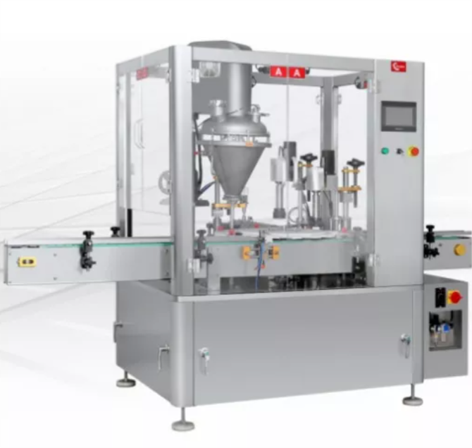
PPG-50F Automatic Powder Filling and Capping Machine for High-Precision Packaging
The PPG-50F Automatic powder filling and capping machine is an efficient solution for powder packaging needs. It is designed to handle a wide range of powder products with accuracy and speed. This machine ensures precise filling and secure capping, making it suitable for industries like food, pharmaceuticals, chemicals, and cosmetics.
Equipped with a dual-head filling system, the machine offers a filling range of 3 to 500ml by simply replacing the screw. Its production capacity of 30-50 bottles per minute makes it ideal for medium to high-volume production lines. With a filling accuracy of 0.75%, it minimizes material loss and ensures consistent results.
The PPG-50F includes a 30L dual hopper for continuous operation without frequent refilling. It operates with a compressed air system and requires 380V/220V power, making it energy-efficient and compatible with standard industrial setups. Its compact design and robust structure ensure reliability and ease of integration into your production line.
This automatic powder filling and capping machine is user-friendly, featuring simple controls for adjusting filling volume and speed. It is widely recognized for improving productivity and maintaining consistent packaging quality.

